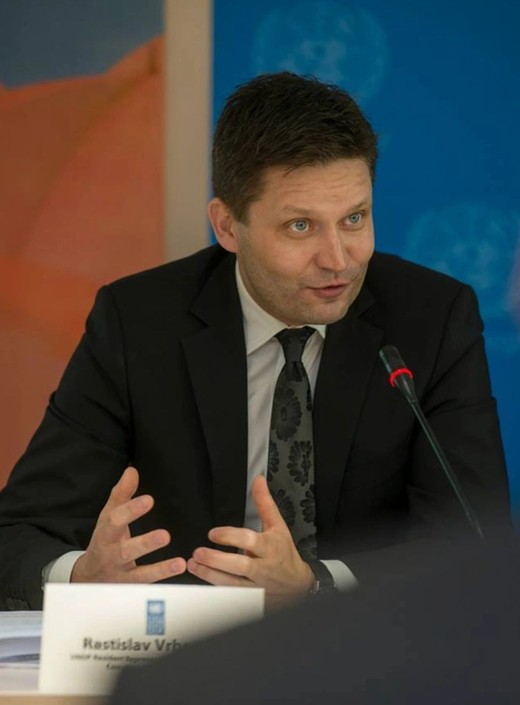
Rastislav Vrbensky
Dr Rastislav Vrbensky - experienced development executive, advisor and lecturer, who has been leading large teams in best international organisations, including UN and UNDP. Knowledge, expertise and hands-on experience in sustainability, climate and innovation. Research and teaching in leading academic institutions.

